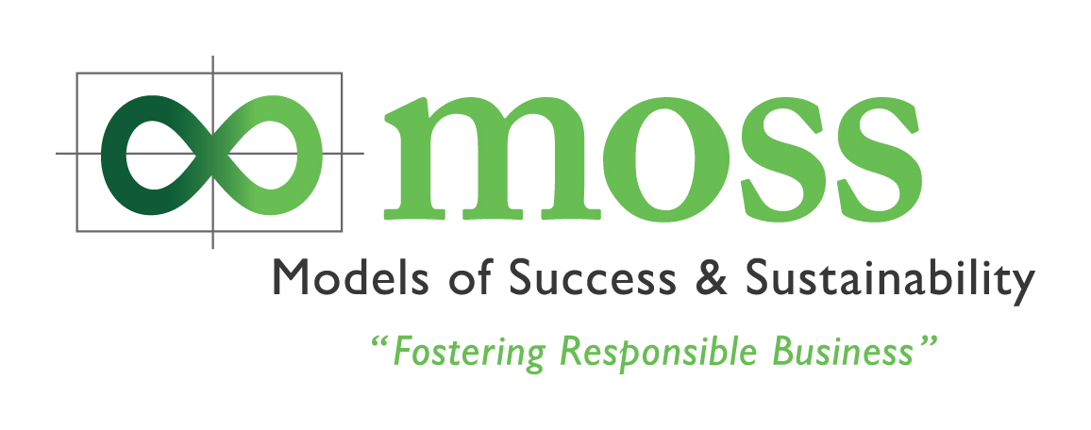

COP 15 Briefing Event Questionnaire Melbourne

MOSS aims to support Australian business through education, training, networking and advice to drive sustainability and competitive business success. In order for us to deliver education in accordance to market needs, we would greatly appreciate you taking a few minutes to complete this questionnaire.

Name:

Organisation:

- Overall how would you rate the COP 15 Copenhagen Briefing
(PLEASE TICK the description that best suits your views)

 | Excellent | Very good | Good | Neither | Poor | Don’t Know
Overall Event rating

- What makes you give it that rating?

Q.3 How would you rate the event in terms of:

 |  | Excellent | Very good | Good | Neither | Poor | Don’t Know
Overall Content
New information
Useful information
Overall case studies and examples
How the information was presented or delivered
Inspiration
Addressing your issues or questions
Value for money
Presenter knowledge
Willingness to share information
Venue
Catering
Learning’s and insights by Louise Hicks – Partner DLA Phillips Fox
Learning’s and insights by Anne-Maree Huxley - MOSS
Learning’s and insights by Sara Gipton - Greenfleet
Learning’s and insights by Amy Kean - Pinpoint Earth
Learning’s and insights by Simon Holmes a Court, Hepburn Wind

PTO
Q.4 What did you most like about the event

Q.5 What did you least like about the event

Q.6 Would you encourage others to attend a similar event  Yes  No

Q.7 In 50 words or less, how would you best describe the benefits of the forum for you and or your
organisation?

Q.8 Would you be willing to allow us to use this to help market the event?  Yes  No

Q.9 What other topics around CSR / Sustainability are you interested in learning about?

Q. 10 Would you be interested in receiving the free MOSS bi-monthly electronic newsletter?

 Yes  No

Q. 11 Would you be interested in receiving invitations to other MOSS Events?

 Yes  No

Q.12 Would you be interested in attending COP 16 in Mexico?

 Yes  No

Q.13 Would you be interested in showcasing at CO 16 in Mexico?

 Yes  No

Many thanks for taking the time to complete this questionnaire. It is greatly appreciated.
Anne-Maree Huxley
CEO MOSS

